Homework Set #3

Assigned: Friday, 2/15 Due: Friday, 2/22 (start of lecture)

This assignment covers textbook material in Chapters1-4.
Note: Refer to course web site for homework policies.

- (10 points) Textbook, Problem 4-4 (f) on p. 86 (upper bound only).

- (15 points) Use the Master Theorem to obtain tight bounds on the closed-form solution to each of the following recurrences:
a) 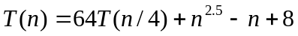
b) 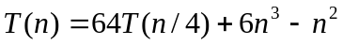
c) 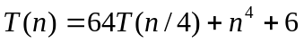
Assume that T (n) is constant for sufficiently small n.

- (30 points) In the problem below, you may assume that n is a power of 5. Justify your answers.

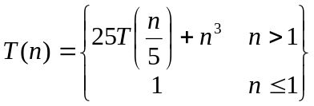

    - Use the Master Theorem to find asymptotic upper and lower bounds on the closed-form solution for T( n). Make the bounds as tight as possible.
    - Use a recursion tree to find asymptotic upper and lower bounds on the closed-form solution for T( n). Make the bounds as tight as possible.
    - Use mathematical induction (with substitution) to verify your upper and lower bounds.

6. (45 points) Pseudo-code Analysis: For the pseudocode below for Mystery, find a tight upper bound on its worst-case asymptotic running time T( n), where n is the length of the portion of array A that is processed by Mystery. That is, find g(n) such that 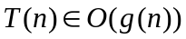, where n = right – left + 1. You may assume that n is a power of 2. Justify your answer.

